Project plan
Author: Abdulrahman Sakah, absk20@student.bth.se



Project Overview

Project assignment

The project i am working is a digital corona vaccine platform where patients can get a secure Qr code to be scanned and view all of the patients vaccine for better control over the corona pandemic.

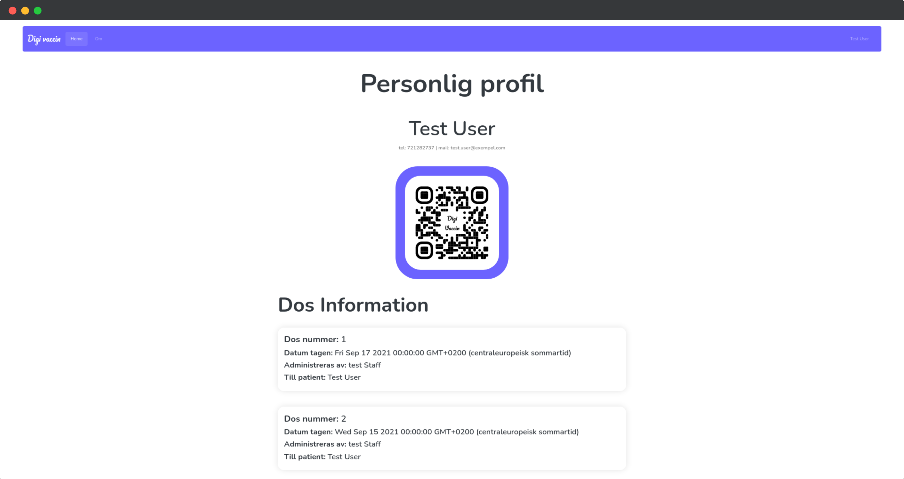

Development methodology

During the development of this project I chose to go with the Agile development method and the reason for that is that this is the development method I am most comfortable with and it is the development that I see best fit for solo development projects.

The way I approached the agile development method in this project was by first planning all the basic stuff I needed to do after that decided them into potential sprints, after dividing the sprints I started with the first sprint which was to start developing the design code and the server side of the project.

Budget

During the development I gave my self a bit more time then I needed to be able to take care of potential complications during development.

Activity | Planned hours/Effort | Actual hours/Effort | Comments
Design code | 18 | 10
Database | 6 | 2
Patient login | 5 | 6 | Problems with database connection (solved)
Display patient information | 3 | 1
Staff login | 5 | 1
Staff page | 10
Mobile application | 72
Login system | 8
Patient information | 5
Staff Qr scanning | 5

Time line

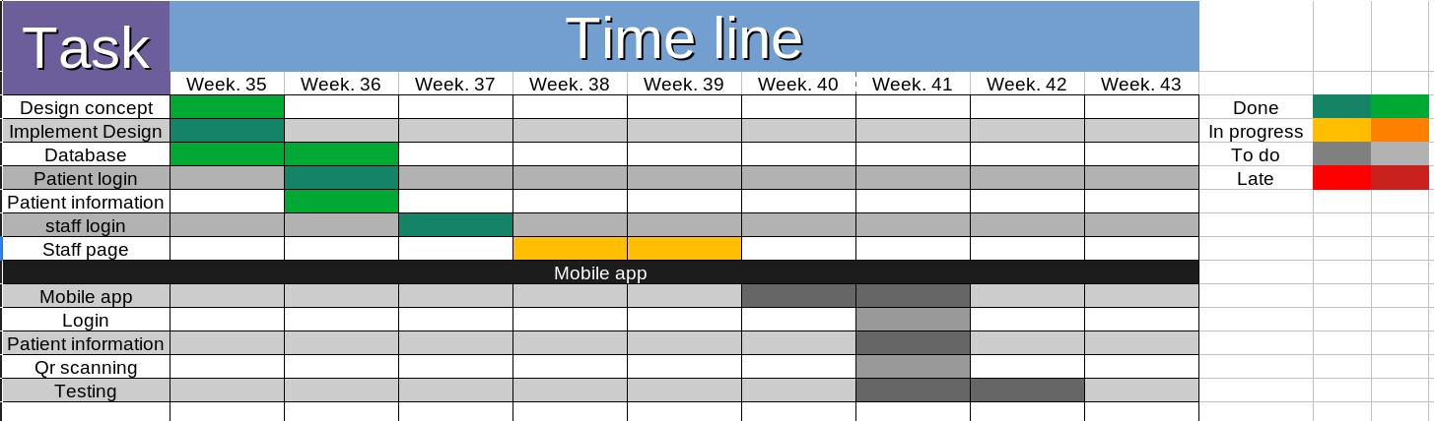

Procedures and routines

The first thing I did working on this project was version control where I used Git for it.

When it comes to risk management I am working on keeping everything update to prevent any zero day exploits in the website, other then that I am parsing every query that is sent to the database to prevent any SQL injection.

Another big exploits that hackers can use are cookies where they can spoof the users cookies and for that I am using non default cookie names and I am using express-session as a middle-ware to prevent these types of attacks.

In the end I disabled the X-powered-by header response to make sure that the technologies I am using are not easy to find which makes the hackers job even harder.

Requirements
In this section you shall fill in what requirements you have noticed and list them down in a structure so that it is possible to separate the different requirements in a good way e.g. as below, but you may use any structure like if you get a official structure to follow.

Requirements : Initial, Committed and Delivered

Requirements
Customer requirements | Requirements committed | Requirements delivered | Comments deviation
Functional requirements
RQ01……..
……..
………
………
Non-functional requirements
RQ01……..
- Usability
RQu01…….
- Capacity
RQc01…….
- Accessibility
RQa01…….
- Maintainability
RQm01……..

If you are following an Agile way then it might be better for you to do a Product Backlog list where you list down the requirements still with the possibility to understand if it is a functional or non-functional requirement. And if I shall be able to see what you have Committed then you also need to bring in the Sprint Backlog list

The question that I see support the model above are:

- What requirements did the customer have in total?
- What requirements were committed (promised)?
- What requirements were actually delivered ?
Hours or effort will be presented in your time sheet that you see under Budget and Time above

Technical solution
- Describe what technical solution will be used and what architecture you see is possible, why this is the best for the customer.
- When at the project end describe changes or deviations just to the original plan
- When at the end of the project make an analysis of the technical solution. What worked well? Any problems challenges, could you have done something different?

Risk management
Attach a risk analysis that you will do at start already then use that as reference when answering :
- Which of the identified risks happened and how well your risk management approaches worked?
- Which risks did you miss? Why?
- Which of the risks that you initially identified as serious risks actually did not and up being risk at all?

Test
  - Describe what test approach will be used and why you think this is the best for your customer
  - Make some test statistics (what was tested when and how?)

